КЫЗЫЛОРДИНСКИЙ УНИВЕРСИТЕТ ИМЕНИ КОРКЫТ АТА


ЛАБОРАТОРНАЯ РАБОТА №6
MySQL

Предмет: Введение в управление данными
Преподаватель: Кулмурзаев Нурлан Серикович
Выполнил: Ким Р.

Кызылорда 2026
Adding keys by ALTER TABLE
- Set the StudentID column in the Students table as the Primary Key.
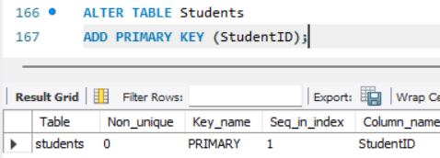
- Set the CourseID column in the Courses table as the Primary Key.
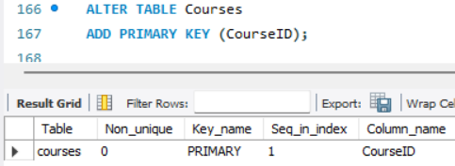

- Set the EnrollmentID column in the Enrollments table as the Primary Key.
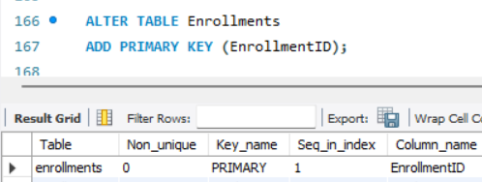
- Add a Foreign Key to the StudentID column in the Enrollments table that references the Students table.
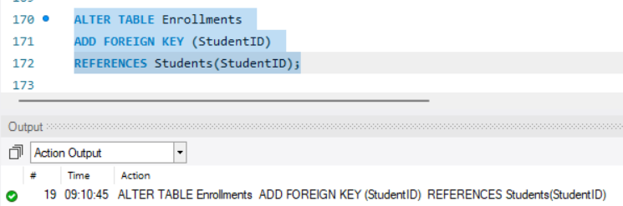
- Add a Foreign Key to the CourseID column in the Enrollments table that references the Courses table.
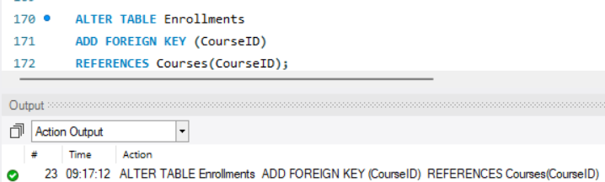

Populating new columns (UPDATE)
- Populate the newly added BirthDate column in the Students table. For example, assign '2004-05-12' to StudentID. Update the table to give all 10 students random birth dates.

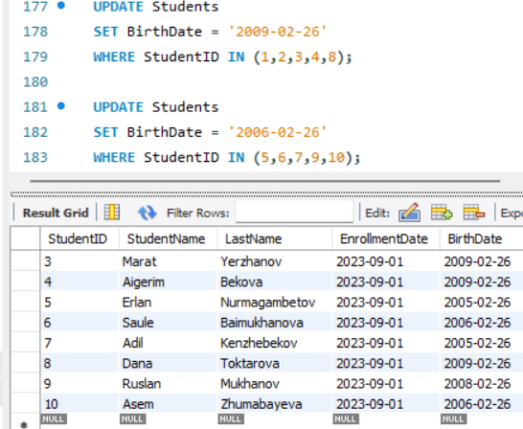
- Populate the Email column in the Students table. Assign an email to each student in the format "firstname.lastname@university.edu".

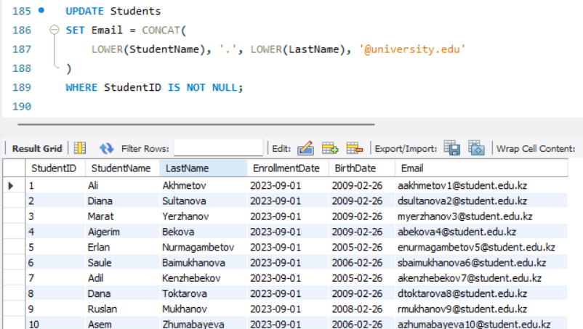
- Add a short description for each course in the Description column of the Courses table (e.g., update 'Machine Learning' with 'Introduction to AI algorithms').
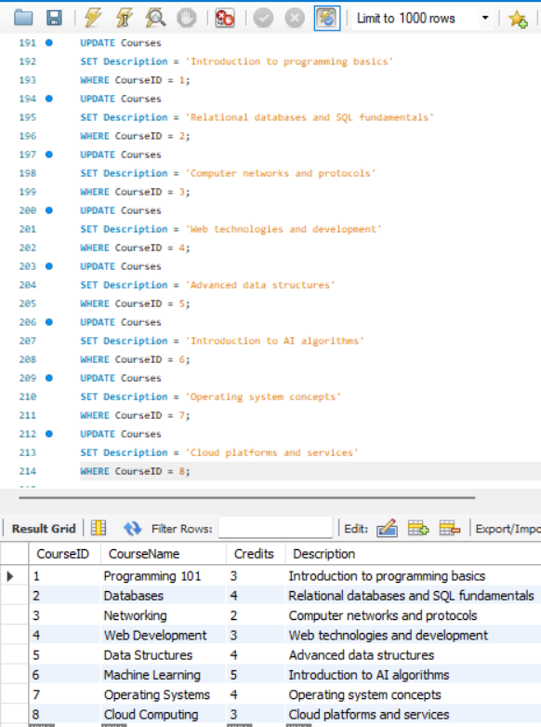
- Populate the GradingDate column in the Enrollments table with datetime values (e.g., '2023-12-20 10:00:00') to represent when each grade was given.

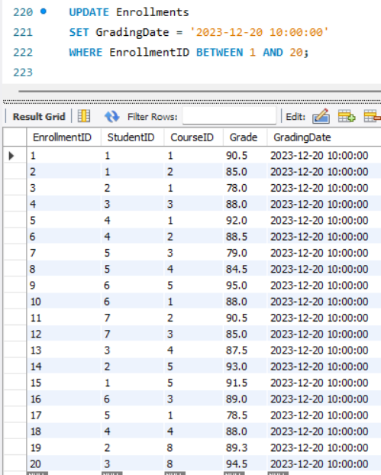
- Update the boolean IsActive column in the Courses table. Set it to TRUE (1) for all courses except for 'Cloud Computing' (CourseID = 8), which should be FALSE (0).
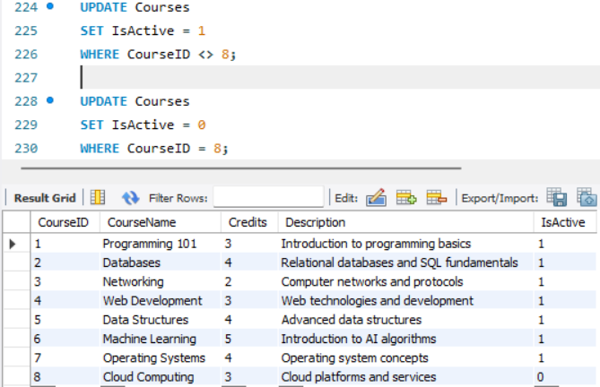
Creating and populating a new table
- Create a new table named Instructors. It should have the following columns: InstructorID (Primary Key), FirstName (VARCHAR), LastName (VARCHAR), and Department (VARCHAR).

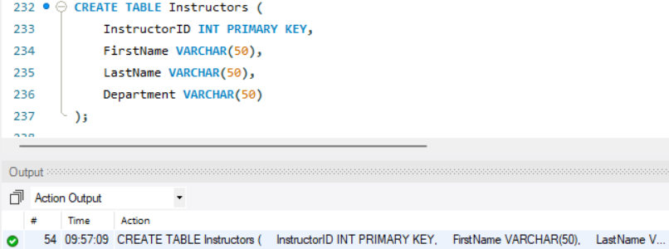
- Use the INSERT INTO statement to add details for at least 3 instructors into the Instructors table (e.g., 1, 'Timur', 'Ospanov', 'Computer Science').
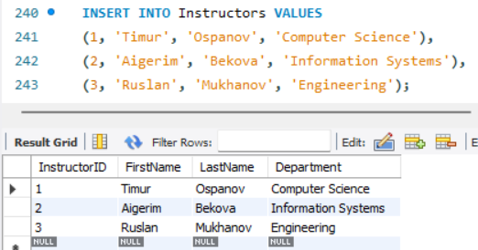

- Use the ALTER TABLE command to add a new column named InstructorID (INT) to the existing Courses table.

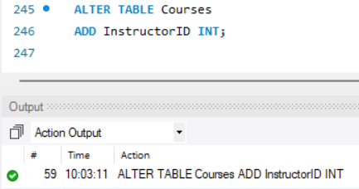
- Use the UPDATE command to assign the newly created Instructor IDs to the InstructorID column in the Courses table.

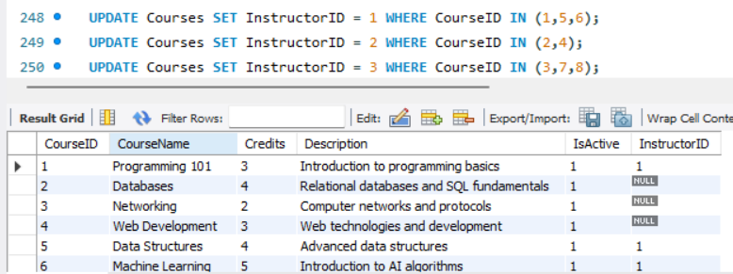
- Set the InstructorID column in the Courses table as a Foreign Key referencing the Instructors table.
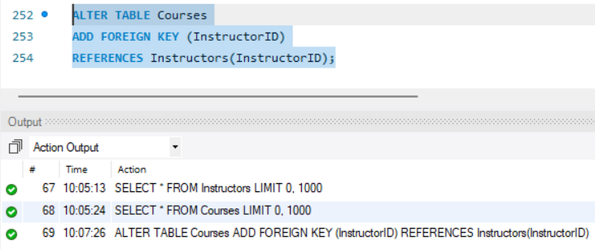

SET operators
- UNION: Combine the first names (FirstName) of all students from the Students table and all instructors from the Instructors table into a single result set.

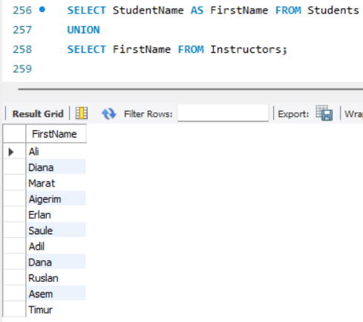
- UNION ALL: Combine the first names of students and instructors again, but this time ensure that any duplicate names remain in the final list.

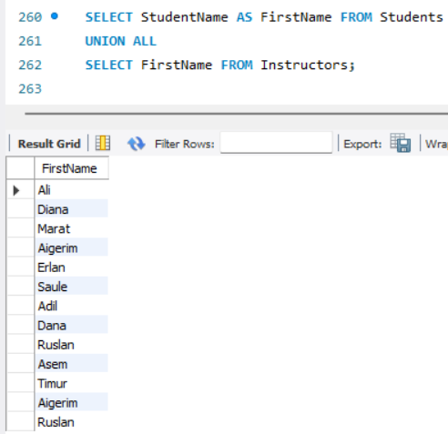
- INTERSECT: Find the Student IDs of students who are enrolled in BOTH "Programming 101" (CourseID = 1) and "Data Structures" (CourseID = 5).
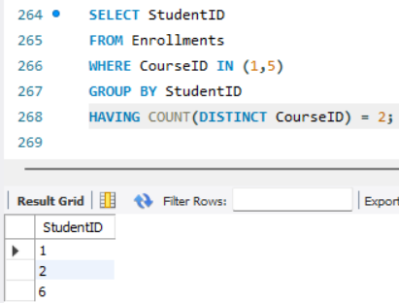

- EXCEPT: From the list of all enrolled students (using StudentID in the Enrollments table), remove the students who are taking "Networking" (CourseID = 3) and display the remaining list of IDs.

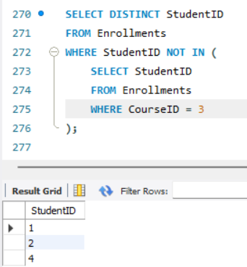
- Use UNION to create a single result set that displays the names of courses worth 4 credits alongside the first names of students who scored higher than 85. (Tip: Add a static text column named 'Entity Type' with values like 'Course' or 'Student' to make the data make sense together).

